Name:Vishal Singh

Class:TYBCA(science)

Roll no:12939(Sybca-sci)

Topic:R programming lab book

QUES.1) Write a R program to add, multiply and divide two vectors of integer type. (vector length should be minimum 4)

CODE::

> x=c(1,2,3,4)

> print(x)

[1] 1 2 3 4

> y=c(5,6,7,8)

> print(y)

[1] 5 6 7 8

> z=x+y

> print(z)

[1] 6 8 10 12

> a=x*y

> print(a)

[1] 5 12 21 32

> b=x/y

> print(b)

[1] 0.2000000 0.3333333 0.4285714 0.5000000

Ques.2) Write a R program to calculate the multiplication table using a function.

CODE::

num = as.integer(readline(prompt = "Enter any number you want : "))

for(i in 1:10)

{

print(paste(num,'x', i, '=', num*i))

}

Ques.3) Write a script in R to create a list of employees and perform the following:

Display names of employees in the list. Add an employee at the end of the list. Remove the third element of the list.

CODE::

employees<-list("Vishal","arya","swati","jyoti","ginny")

print("Original List be like")

print(employees)

employees[6]<-"Arti kumari"

print("After adding new element in the list")

print(employees)

employees[3]<-NULL

print("After removing a element from the list")

print(employees)

Ques 5.) Write a R program to reverse a number and also calculate the sum of digits of that number.

CODE::

n = as.integer(readline(prompt = "Enter any number :"))

rev = 0

sum=0

while (n > 0)

{

r = n %% 10

sum=sum+r

rev = rev * 10 + r

n = n %/% 10

}

print(paste("Reverse number is ::", rev))

print(paste("Sum of the number is ::",sum))

Ques 6.) Write a R program to calculate the sum of two matrices of given size.

CODE::

a=matrix(c(1,2,3,4,5,6,7,8,9),byrow=3,ncol=3)

print(a)

b=matrix(c(11,12,13,14,15,16,17,18,19),byrow=3,ncol=3)

print

z=a+b

print(z)

Ques 7.) Write a R program to concatenate two given factors.

CODE::

f1 <- factor(sample(LETTERS, size=10, replace=TRUE))

f2 <- factor(sample(letters, size=5, replace=TRUE))

print("Original factors:")

print(f1)

print(f2)

f = factor(c(levels(f1)[f1], levels(f2)[f2]))

print("After concatenate factor becomes:")

print(f)

Ques 8.) Write a R program to create a data frame using two given vectors and display the duplicate elements.

CODE::

a=c(1,2,3,4,5,6)

b=c(1,3,6,7,5,9)

print("Original data frame :: ")

ab=data.frame(a,b)

print(ab)

print("Duplicate elements in the data frame is :: ")

print(duplicated(ab))

print("Unique elements in the data frame is :: ")

print(unique(ab))

Ques 9.) Write a R program to perform the following:

Display all rows of the data set having height greater than 120.

Display all rows of data set in ascending order of weight.

1. (Use inbuilt data set woman)

CODE::

subset(women,height>60)

print(women[order(women$weight), ])

Ques 10.) Write a R program to perform the following:

Display all the cars having mpg more than 20. Subset the data set by mpg column for values greater than 15.0 Display all cars having four gears. (Use inbuilt data set mtcar)

CODE::

subset(mtcars, mpg >= 20)

subset(mtcars, mpg >= 15)

subset(mtcars,gear==4)

Ques 11.) Write a R Program to perform the following:

Create a Scattered plot to compare wind speed and temperature.

Create a Scattered plot to show the relationship between ozone and wind values by giving appropriate values to colour argument. Create a Bar plot to show the ozone level for all the days having temperature > 70. (Use inbuilt datasetair quality)

CODE::

library(ggplot2)

airquality$Month<-factor(airquality$Month)

qplot(Wind,Temp,data=airquality,color=Month)

qplot(Wind,Ozone,data=airquality,color=Month)

__________________________________________________________________________________________________________________________________________________________________________________________________________________________________________________________________________________________________________________________________________________________________________________________________________________________

* Assume that we have registered the height and weight for four people: Heights in cm are 185, 175, 163, 193; weights in kg are 97, 68, 95, 100. Make two vectors, height and weight, with the data. display both vectors.

CODE::

height<-list(175,163,193,185)

weight<-list(97,68,95,100)

print("Height of the four people be like :: ")

print(height)

print("Weight of the people be like :: ")

print(weight)

* Try the given command and explain what you see: C+D, C-D, C*D where C and D are matrices.
* The determinant of a square matrix is computed with the det function. Find the determinants of C and D. Are the matrices regular or singular? What happens if you write det(A)?

CODE::

C=matrix(c(1,2,3,4,5,6,7,8,9),byrow = 3,ncol=3)

print("Matrix C :: ")

print(C)

D=matrix(c(11,12,13,14,15,16,17,18,19),byrow = 3,ncol=3)

print("Matrix D :: ")

print(D)

print("Addition of two matrix :: ")

print(C+D)

print("Subtraction of two matrix :: ")

print(C-D)

print("Multiplication of two matrix :: ")

print(C*D)

print("Determinant of matrix C :: ")

print(det(C))

print("Determinant of matrix D :: ")

print(det(D))

*Try any five built-in mathematical functions in R programming. and explain each in your own way.

CODE::

x<- -9

print(abs(x)) #It returns the absolute value of x

y<-144

print(sqrt(y))#It returns the square root of value of y

z<-8.9

print(ceiling(z))#It returns the value which after the decimal point

a<-8.9

print(floor(a))#It returns the value which before the decimal point

b<-12

print(log(b))#It returns the log value of 12 with base of 10.

* Assume that you are interested in cone-shaped structures, and have measured the height and radius of 6 cones. Make vectors with these values as follows:

R <- c(2.27, 1.98, 1.69, 1.88, 1.64, 2.14)

H <- c(8.28, 8.04, 9.06, 8.70, 7.58, 8.34)

Recall that the volume of a cone with radius R and height H. Make a vector with the volumes of the 6 cones.

CODE::

R <- c(2.27, 1.98, 1.69, 1.88, 1.64, 2.14)

H <- c(8.28, 8.04, 9.06, 8.70, 7.58, 8.34)

volume<-c(1/3*pi*R^2*H)

print("Volume of the cone is :: ")

print(volume)

CASE STUDY::

Ques.))Consider screentime usage of your phone for continuous 8-10 days. Smartphone shows report for this. Note down timings in one file. Later, display day-wise bar plot for this.

CODE::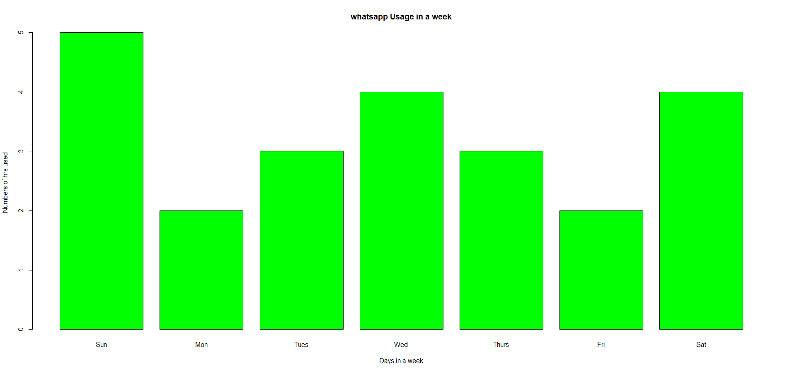

Days=c("Sun","Mon","Tues","Wed","Thurs","Fri","Sat")

Usage=c(5,2,3,4,3,2,4)

barplot(Usage,xlab="Days in a week",ylab="Numbers of hrs used",main="whatsapp Usage in a week",col="green",names.arg=Days)